**TARANNUM ( IMS )**

**ACHIEVEMENTS 2023-24**

Tarannum ( IMS ) of Jesus and Mary College has long been a beacon of cultural enrichment, dedicated to preserving and promoting rich heritage of Indian Classical Music.

The society’s most notable achievements in the session 2023-24 are as follows:

* GROUP ACHHIEVEMENTS:

1. Secured the 1st position in ‘ALAAP’ – Group Singing Competition organized by ‘Tehzeeb’ (RML) the cultural committee of Dr. Ram Manohar Lohia National Law University.

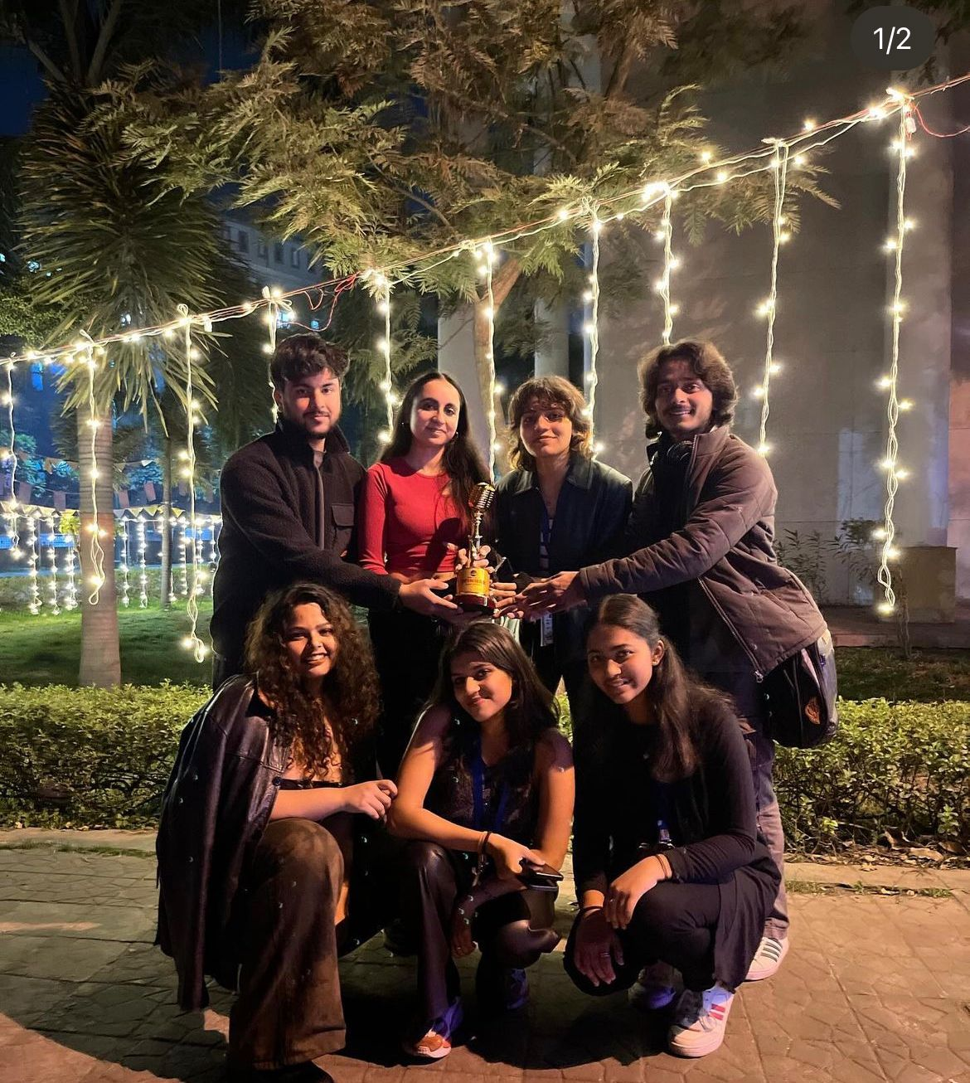

1. Secured the 2nd position at ‘RAAGMALA’ – The Indian Classical Music Competition organized by the Indian Music Society ‘ Dhwani ’of Shaheed Sukhdev College Of Business Studies.

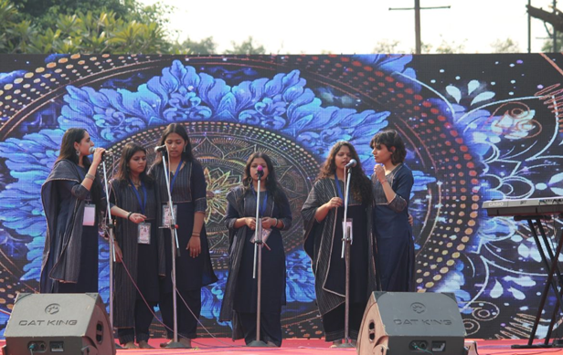

* SOLO ACHIEVEMENTS:
* Soloist - Ananya Gaur

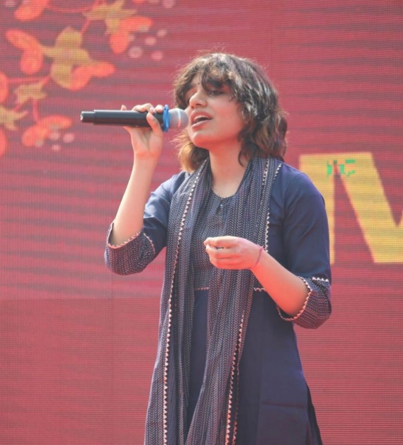

1. Placed 2nd in ‘SWAR’ – THE SEMI-CLASSICAL/ BOLLYWOOD SOLO SINGING COMETITION hosted by ‘Roots’ – The Indian Music Society, Dyal Singh College.
2. Secured the 2nd position in ‘Andholika’ – The Eastern Music Competition conducted during ‘Oasis 23’ organized by The Music Society of BITS PILANI.
3. Placed 3rd in ‘Kalaavant’ – The Solo Semi-Classical competition hosted by ‘Alankaar’ – The Indian Music Society of Hindu College, DU.

* Soloist – Jia Jimmy Mattam

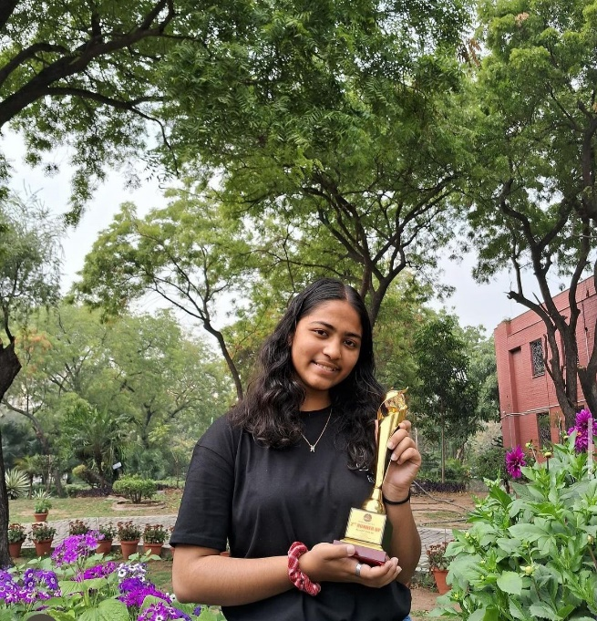

1. Secured the 3rd position in ‘ALAAP’ – The Solo Singing Competition organized by ‘Tehzeeb’ (RML) the cultural committee of Dr. Ram Manohar Lohia National Law University.

* Soloist – Priyanshi Saxena

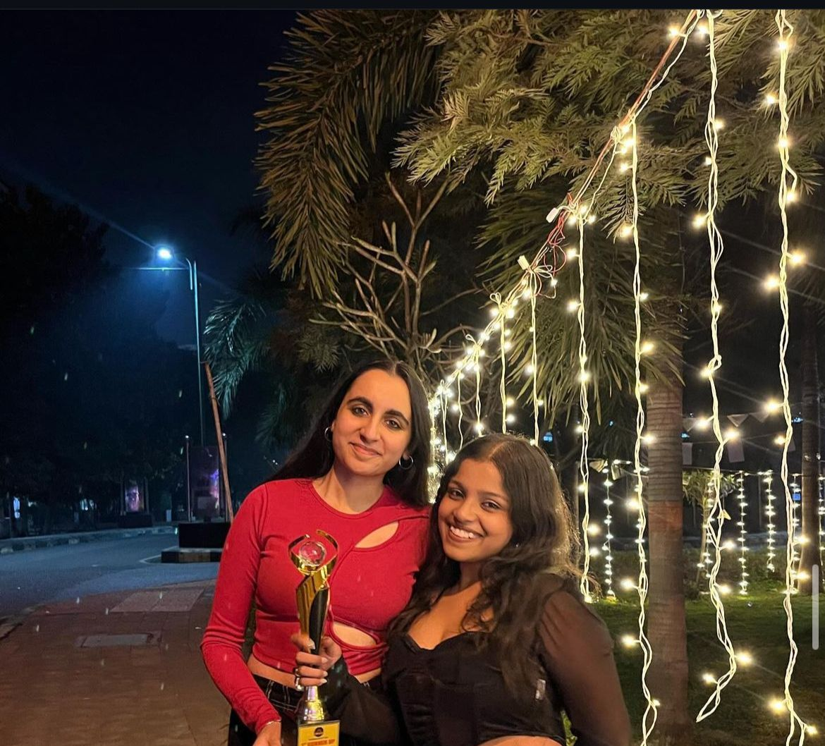

1. Our Soloist Priyanshi Saxena accompanied by Tavleen Kaur bagged the 2nd position in ‘ALAAP’ – The Solo Singing Competition organized by ‘Tehzeeb’ (RML) the cultural committee of Dr. Ram Manohar Lohia National Law University.